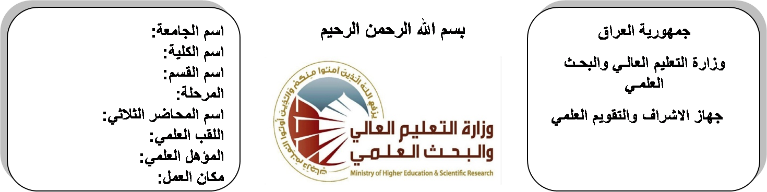

**اسم الجامعة:ديالى**

**اسم الكلية:الهندسة**

**اسم القسم:الالكترونيك**

**المرحلة:الثالثة**

**اسم المحاضر الثلاثي:عدنان محمد طه**

**اللقب العلمي: مدرس مساعد**

**المؤهل العلمي:ماجستير**

**مكان العمل: كلية الهندسة**

**(( استمارة الخطة التدريسية السنوية ))**

|  |  |  |  |  |
| --- | --- | --- | --- | --- |
| **عدنان محمد طه** | | | | **اسم التدريسي:** |
| **adnanalmamoory@gmail.com** | | | | **البريد الالكتروني:** |
| Communication Theory | | | | **اسم المادة:** |
| **The aim of this subject is to make the students ready to undestand and comprehend the scientific theories and their applications related to their field of the study.** | | | | **أهداف المادة:** |
| Modern digital and analoge communications by Marten | | | | **الكتب المنهجية:** |
| Digital and analoge communications systems byLeon W.couch | | | | **المصادر الخارجية:** |
| **الامتحان النهائي** | **المختبرات** | **الفصل**  **الثاني** | **الفصل الأول** | **تقديرات الفصل:** |
| 50% | 10% | 20% | 20% |
|  | | | | **معلومات إضافية:** |

**جدول الدروس الأسبوعي – الفصل الدراسي الأول**

|  |  |  |  |  |  |
| --- | --- | --- | --- | --- | --- |
| **الملاحظات** | **المادة العملية** | **المادة النظرية** | **التاريخ** | | **الأسبوع** |
|  |  | Communication system elements (Signal analysis) | **29/9/2015** | | 1 |
|  |  | Signal classification of periodic and non periodic signals | **5/10/2015** | | 2 |
|  |  | classification of systems | **12/10/2015** | | 3 |
|  |  | power spectral density and correlation | **19/10/2015** | | 4 |
|  |  | Noise | **26/10/2015** | | 5 |
|  |  | power calculation, thermal white Gaussian noise (AWGN) | **2/11/2015** | | 6 |
|  |  | band-limited noise (base band and bandpass) noise through linear systems. | **9/11/2015** | | 7 |
|  |  | liner modulation (AM) | **16/11/2015** | | 8 |
|  |  | AM\DSB-SC | **23/11/2015** | | 9 |
|  |  | AM/DSB-LC | **30/11/2015** | | 10 |
|  |  | AM/SSB-SC | **7/12/2015** | | 11 |
|  |  | AM/VSB | **14/12/2015** | | 12 |
|  |  | frequency division multiplexing (FDM) | **21/12/2015** | | 13 |
|  |  | commercial receivers (TRF and superheterodyne), and noise in AM systems | **28/12/2015** | | 14 |
|  |  | Angle modulation | **4/1/2016** | | 15 |
|  |  | NBFM, NBPM, WBPM | **11/1/2016** | | 16 |
| عطلة نصف السنة | | | | 15/1/2016 to  1/2/2016 | |

**توقيع الأستاذ: توقيع رئيس القسم توقيع العميد:**

**جدول الدروس الأسبوعي – الفصل الدراسي الثاني**

|  |  |  |  |  |
| --- | --- | --- | --- | --- |
| **الملاحظات** | **المادة العملية** | **المادة النظرية** | **التاريخ** | **الأسبوع** |
|  |  | WBPM | **21/2/2016** | 1 |
|  |  | noise in angle modulation systems | **28/2/2016** | 2 |
|  |  | Transmission lines | **6/3/2016** | 3 |
|  |  | Equivalent circuit, characteristic impedance | **13/3/2016** | 4 |
|  |  | phase velocity | **20/3/2016** | 5 |
|  |  | reflection coefficient | **27/3/2016** | 6 |
|  |  | standing waves, quarter-wave transformer | **3/4/2016** | 7 |
|  |  | smith chart calculation and stub matching | **10/4/2016** | 8 |
|  |  | Digital communications | **17/4/2016** | 9 |
|  |  | Nyquist sampling theorem | **24/4/2016** | 10 |
|  |  | pulse modulation PAM, PPM | **1/5/2016** | 11 |
|  |  | Time division multiplexing (TDM), noise in pulse modulation | **8/5/2016** | 12 |
|  |  | pulse code modulation PCM\TDM | **15/5/2016** | 13 |
|  |  | Delta modulation (DM), quantization noise in PCM and DM. signaling format (unipolar, bipolar, &split-phase Mannhester) | **22/5/2016** | 14 |
|  |  | Sinusoidal digital modulation ASK, PSK, FSK , and M-ary | **29/5/2016** | 15 |
|  |  | Noise in ASK, PSK FSK(error probability using coherent matched filter and noncoherent detection) | **2/6/2016** | 16 |

**توقيع الأستاذ: توقيع رئيس القسم توقيع العميد:**